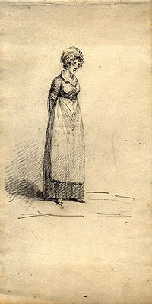
New Girl

we went into a lit well room
It looked proper cosy a good fire
Rest of the room was chill
Felt big and bare.

People sat with their backs to us
Speaking in low voices, then turned our way
Everyone got up
We waved them back into their seats.

“This is our new housemaid Matilda “
I felt myself shrink,
I tried to smile
A dark eyed girl, looked at me coolly.
Not altogether welcoming.

By Caitlin Fisher

