Rising from the Dead
I have been frozen for 125 years
Never waking up again was my biggest fear.
The current world I once called the future,
Is now very different, with advanced computers.
As well as Halloween in October,
Things in this world have you looking over your shoulder.

Jetpacks as daily transportation,
That take you to whatever the location.
Robots are casual to see around the street,
Talking llamas are complementary pets in a hotel suite.
(Cannot imagine what they need that for!)
Unlimited bacon-flavoured floss in almost every store.
Books that read aloud to you when you pick them up
Men in white suits serving opiates in a cup.

The world nowadays is crazy.
Technology has gone way too far,
People are actually asleep driving their car!
I don’t know where to start,
Maybe the idea of being frozen wasn’t so smart.
How long will I stay alive for now?
If the people from my past only knew about this,
They would probably all think,
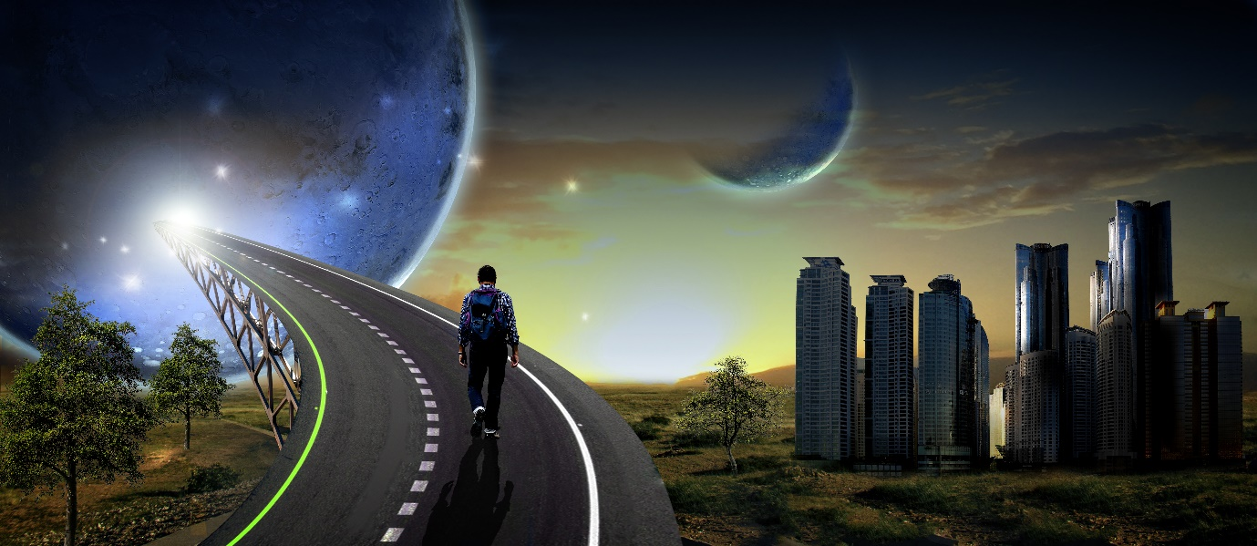
Wow! By Olivia Campbell

