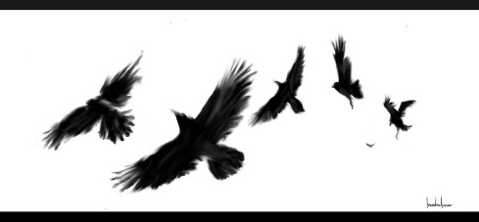
Loss

Fell asleep on the 6th of February 1871.
Goodnight sweet prince.

I’d had a fright.
Tears were streaming down my face.
I was standing pale.

Chill air.
It was quiet.
Different.
The blackbird hopped above me, sweetly singing.

It was real.
The dreams were real.
He was dead.
But he wasn’t truly at rest.

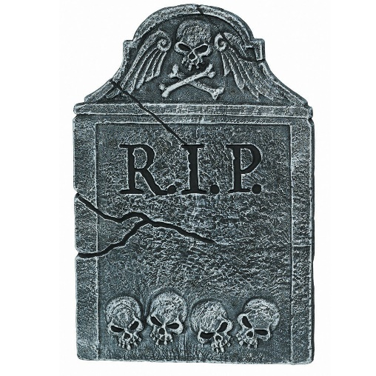
I reached out.
To the boy under the ice.
This was painfully sad.
My throat started to ache.
By Rachel O’Halloran

