I Have Awoken

I have awoken
It took some time,
I was frozen in a place I don’t recognise
But I am finally back.
The world is old and different
Although the atmosphere still remains.
My home no longer exists,
And my family are nowhere to be seen.
I am alone
Everyone and everything I knew has disappeared.
It is so silent,
My thoughts are loud.
It was my choice
I wanted this
There is no going back
I thought coming back would be the exact same,
Like the old times
I thought wrong…

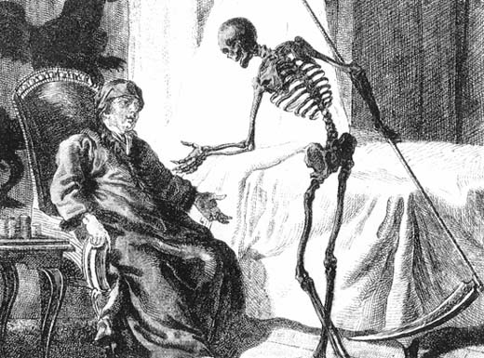
By Caoimhe Scannell

