CREEPY OLD PLACE

It was as quiet as death…
Birds weren’t singing.

Crouching on the grass
Cold air
Shivers go through me
Air felt heavy and chill.

Twisting and turning
Woods thinned
Copse of bare trees
In a gloomy thicket.

Grass was so pale
Trees white like bones
Marvellous frost
Thick white fur.

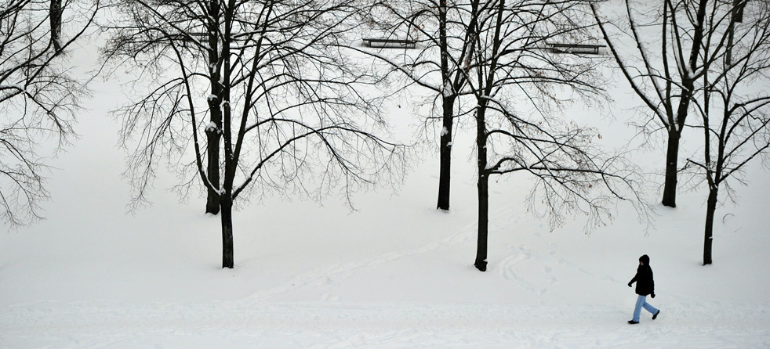
By Esther Olajide

