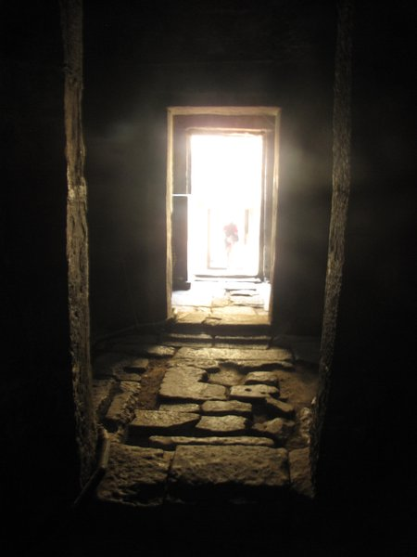
The Passageways
By Teighan McCann
Look.
The giant table
Doors slamming
Little windows
Heat is stifling
Black.

The housekeeper
Frowning
Pushed me forward
‘Up to no good.’

Like a startled rabbit
Back out in the passageway,
I am struck
By how brightly lit it is.
Voices are shouting
Deafening.

A maid comes past,
How pretty she is
Sleek brown hair,
Hidden by her cap.
It’s not fitting for a head housemaid to be here.
It’s not fit for anyone.

