The Girl and the Horse.
By Chloe McCloskey

In California, as the sky darkened, I set off onto the beach. There was a chilly breeze in the air but I was hoping not to be gone long. The beach was filled with salty sea water fumes. The sky spoke loud and strong with thunders.
Suddenly stronger thunder roared and lightening was clear in the sky. Just in time I looked up, in horror I stared as a large branch began to tumble through the sky almost as if it was in slow motion. I panicked and tried to run but there was no time. My body froze and I watched as the huge branch came tumbling, come crashing down on my head. With a thud I fell to the ground, defeated. It took a moment to realise I was stuck. The branch was on top of me. I was secured to the ground below me.
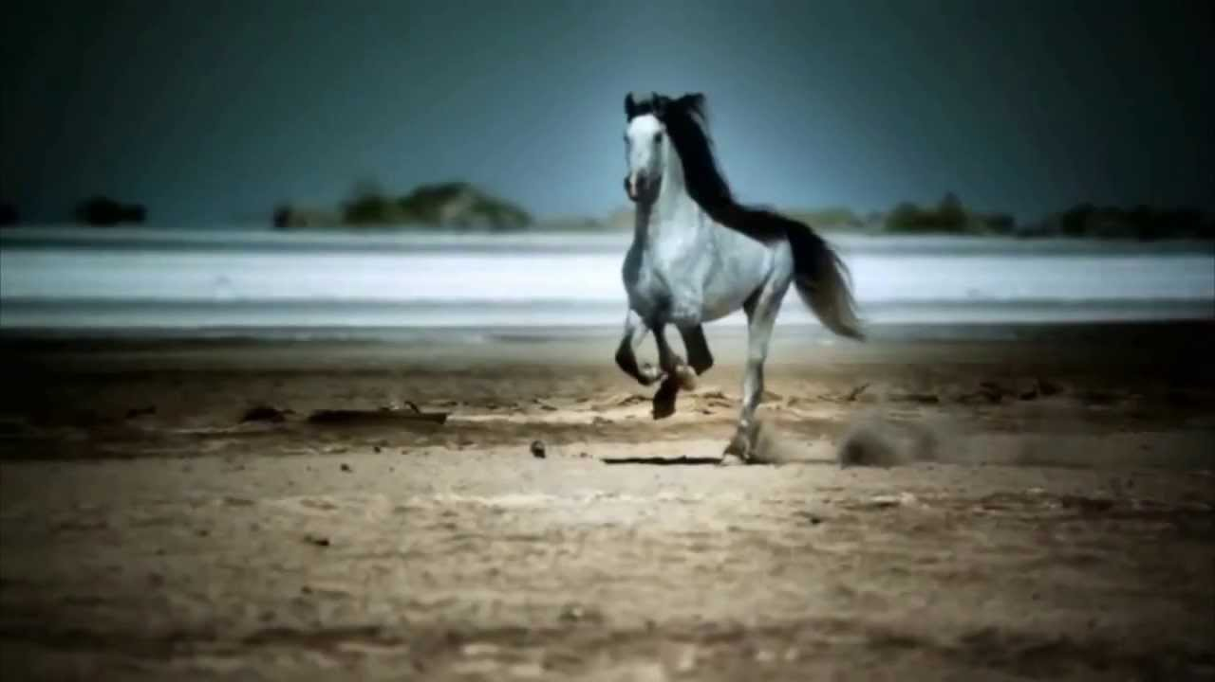
I heard only silence. Nothing but the waves and the strong winds. I was alone. Stuck. A voice spoke behind the waves in the distance, calling out ‘Flight! Flight!’. It made no sense, I slowly opened my eyes to see a white figure in the distance in front of me. As it began to move towards me I realised how close it was to me and a figure began to form a shape until I realised what it was. A horse!

I heard the loud voice again but clearer this time. ‘‘Flight come back here!’ the voice repeated. A boy. I couldn’t recognise who it was, the voice was deep and strong. The air was freezing cold and the tide started to gradually come closer to me.
The horse stopped at my feet. It was beautiful. My head began to hurt more and more until the light begun to fade, and fade…and fade.
I woke up in a warm festive-like living room, by a warm fire with hot tea and food on the table. A boy come walking towards me. Who was this boy?
‘Oh, you’re awake,’ the boy spoke.
Confused, I asked, ‘Do I know you?’
‘No, my name is Gilbert,’ he explained.
‘Why am I here? What do you want from me?’ I protested.
I began to panic.
‘My horse brought you here, Flight. He got out and found you. You were in terrible state. Do you remember what happened?’ he explained.
A horse? It all began to make sense. I started to remember the angel-like horse at the beach, and then the mysterious voice… this must be him I supposed, I wondered why the horse had stopped at me. He could have galloped right past me. Heck he could have trampled me if he really wanted to. But he stopped. I must have been unconscious, and while I was, the horse must have shaken the branch off my body.
‘You alright?’
‘Oh..yeah, I think so.’ I told him.
‘Flight saved your life. If it weren’t for him, you’d be away in the tide by now’.
What he said was true. And it still stuck in my mind. I had to know more about this horse, I had to know why.
‘Well, where is Flight now?’ I asked, hopeful to see him again.
‘Flight’s in his stable, usually he hates the beach. The waves and the sounds scares him, the atmosphere. I guess he is still shaken up from the situation. He has never done this before,’ Gilbert stated with a smile.
‘He was beautiful, almost angel like,’ I tell Gilbert.
I watched as Gilbert spoke about Flight and his eyes sparkled in the moonlight, He was rather angel-like himself. I realised that what started as only a beach walk, led to a crash on the head and to meeting this wonderful boy and an even more wonderful horse.
The End.

