Frosted winter night
Twisted leaves.
Queer-looking flowers.
Loomed before us.

Complete hare-brain.
Swooning.
Mocking me.
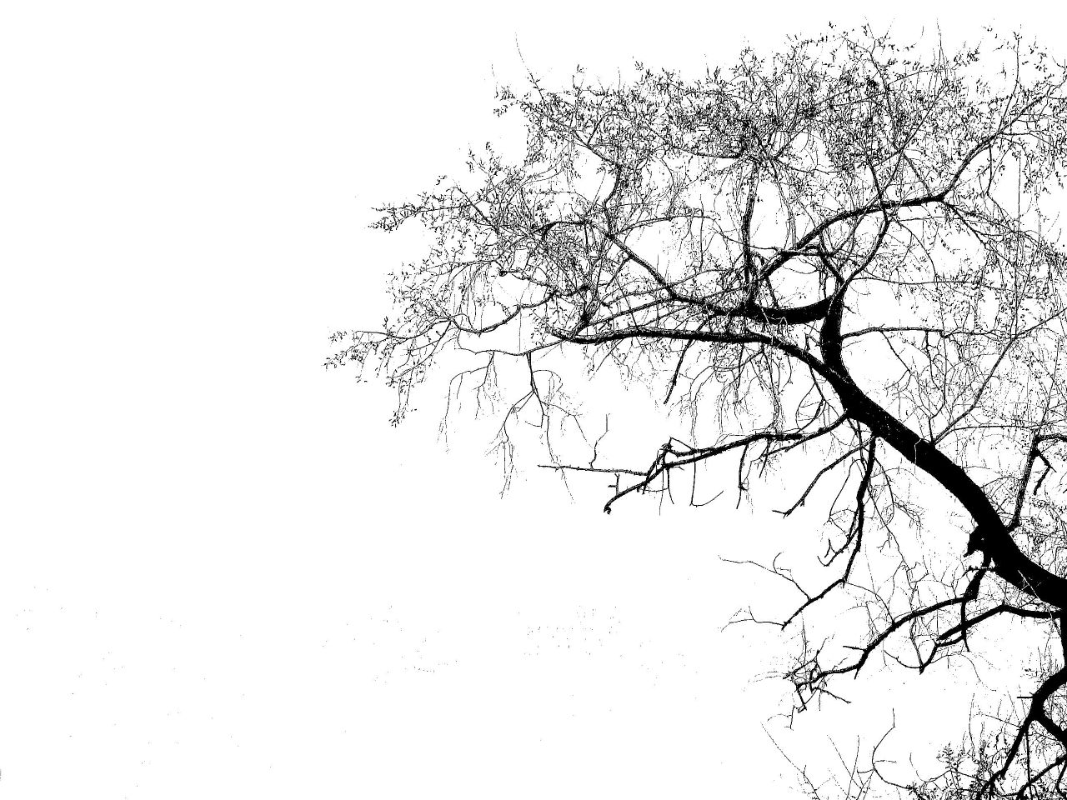
Quiet as death.
Birds weren’t singing.
Shivers go through me.

Narrow path twisted.
Turned between trees.
Slithered downhill.

Thickest, marvellous frost.
Grass was pale.
White like bone.
Sight to behold.
By Leah Gorman

