I am Frankenstein’s Creature

I am the monster under your bed
I am the thing stuck in your head
No one has seen me
No one will look
So, I lurk in the shadows
Entirely mistook

I curse my creator
For my life of dread
I asked him to help me
He tried to kill me instead
I thought he would love me
To prove to the world
That a parent’s love is stronger than all that was hurled

I survived by myself
I tried my best
But I hide from this world with a message to spread
Please do not judge, hate or mistreat
For if someone would help me
I might not be facing the judgement seat.
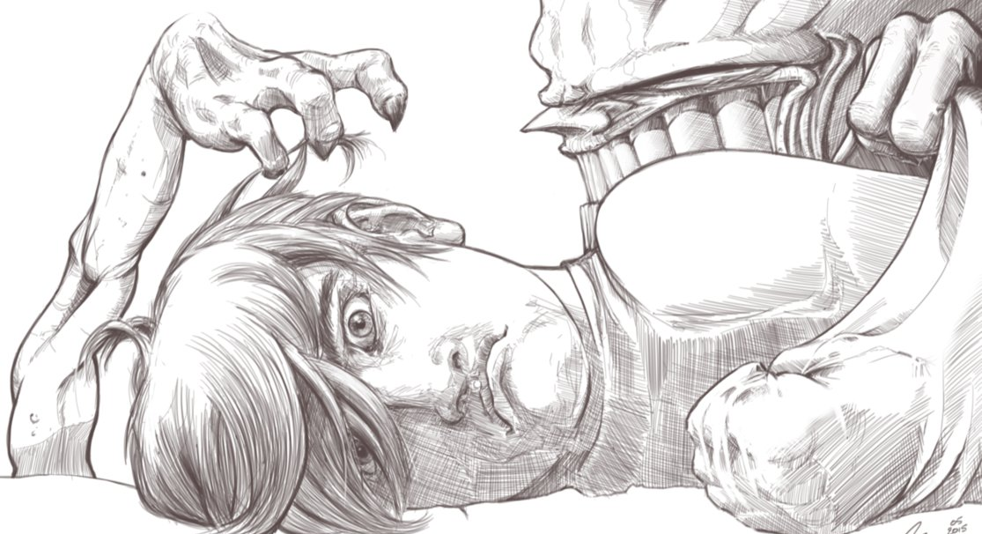
By Aoibh O’Neill

